PYTHONCODE(GAS,TEMPERATURE,HUMIDITY,PRESSURE)

|  |  |
| --- | --- |
| **Date** | 10NOVEMBER2022 |
| **TeamID** | PNT2022TMID02412 |
| **ProjectName** | GAS LEAKAGE MONITORING AND ALERTING SYSTEM FOR INDUSTRIES |

PYTHONCODE

importrandom

print('HazardousGas Level=',str(random.randint(0,100)))print('Temperature=',str(random.randint(0,100)))print('Humidity=',str(random.randint(0,100)))print('Pressure=',str(random.randint(0,100)))

OUTPUT:

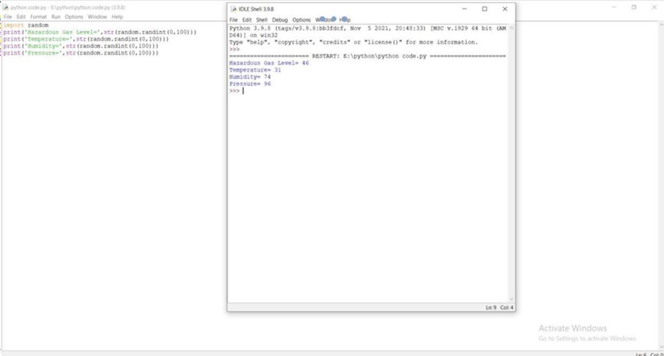

*1*

